**Titanic Survival Analysis Report**

**1. Introduction**

This report explores the factors that influenced passenger survival in the Titanic dataset using Exploratory Data Analysis (EDA).  
Key features such as **gender**, **passenger class**, and **age** were analyzed to uncover insights into survival rates.

**2. Data Preprocessing**

* Missing values in the Age column were filled using the **median**.
* Missing values in the Embarked column were filled using the **mode**.
* The Cabin column was **dropped** due to excessive missing values.
* Categorical columns Sex and Embarked were encoded using **one-hot encoding**.

**3. Visualizations & Insights**

**a. Survival by Gender**

📊 *Observation:* Female passengers had significantly higher survival rates than male passengers.

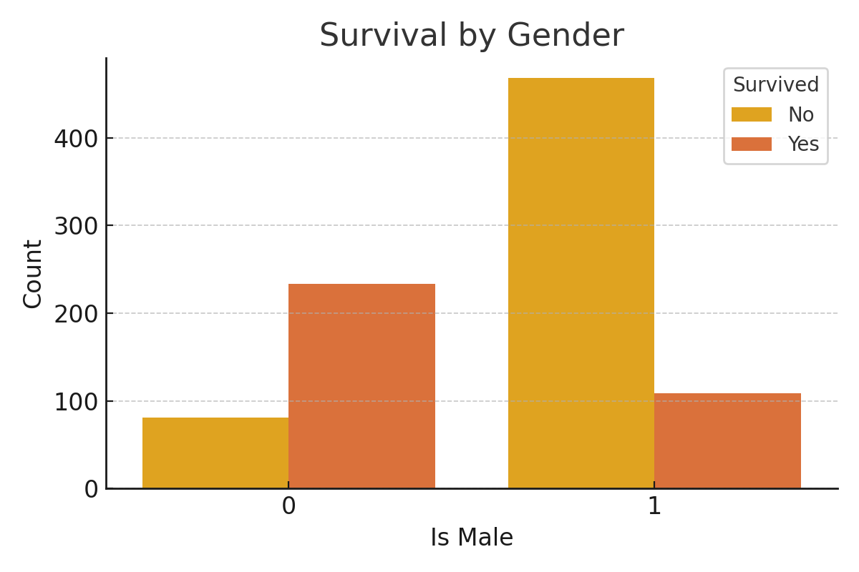

**b. Survival by Passenger Class**

📊 *Observation:* Passengers in 1st class had the highest survival rate, while 3rd class passengers had the lowest.

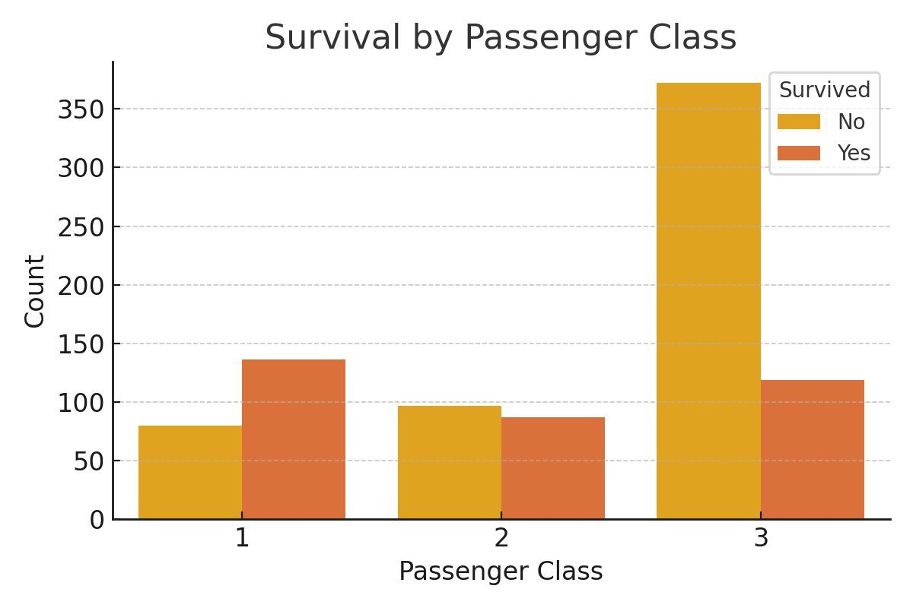

**c. Age Distribution by Survival**

📊 *Observation:* Younger passengers, especially children, had higher survival chances.

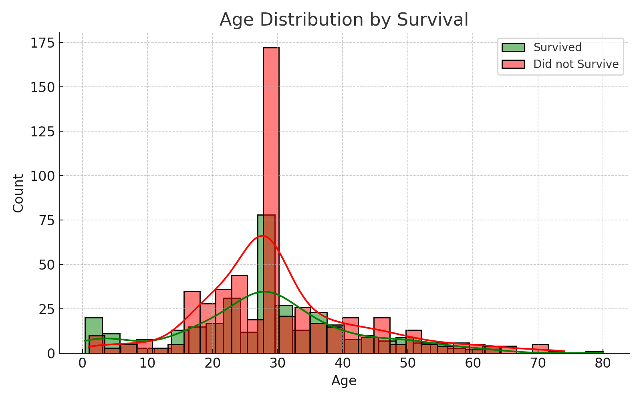

**4. Conclusion**

The analysis indicates that **gender**, **class**, and **age** were significant factors affecting survival chances:

* **Females** had much higher survival rates than males.
* **1st class passengers** had the best survival rates.
* **Younger passengers** (especially children) had better chances of survival.